1 Introduction
Wire Arc Additive Manufacturing (WAAM) is a directed-energy-deposition process based on arc-welding technology. It continuously feeds and melts a metal wire using an electric arc, depositing it layer by layer to manufacture near-net-shape metallic components. (norrish?). Owing to its high deposition rate, high material utilisation, and low feedstock and equipment costs, WAAM is attractive for large, complex components in sectors such as aerospace and marine engineering. However, the process is highly sensitive to parameter variation and thermal accumulation: repeated heating and cooling cycles can produce residual stresses, distortion, porosity, cracking, lack of fusion, humping, balling, and inconsistent bead geometry. Since these deviations compromise dimensional accuracy and mechanical integrity, reliable in-situ monitoring is essential for robust industrial implementation and future closed-loop control of WAAM (gourakani-review?).
Among the observable process signatures, the welding arc provides a direct indication of the WAAM process state, as arc stability is closely associated with droplet transfer, electrical-signal behaviour, and the resulting layer formation (gao?). Here, an unexpected and sustained absence of the visible arc during a commanded deposition path is treated as a process anomaly, which may indicate a dry run, a failed ignition or re-ignition, a wire-feed interruption, or another disturbance that prevents effective deposition. Detecting this quickly reduces wasted machine time and material and can trigger a safe stop before the error propagates into subsequent layers.
Vision-based monitoring provides a practical route to detecting such anomalies. Industrial cameras are non-contact, low-cost, and integrable into robotic WAAM cells to observe arc appearance, melt-pool behaviour, spatter, and bead geometry (xia?; franke?). Intense arc light, reflections, spatter, and changing illumination make image interpretation challenging. However, camera-based sensing offers an external monitoring channel that does not rely exclusively on high-rate internal welding signals.
In a WAAM video the active arc is normally the brightest region, so a naive detector could threshold pixel brightness and declare the arc present whenever bright pixels appear. This fails, because the optical environment is hostile; molten and solidified metal is highly specular and produces bright reflections (Figure 1); The fluctuating arc radiation interacts with the camera exposure to create saturation and glare, and the process emits smoke and fumes. Bright regions other than the arc, such as flashes, reflections, and wire glints, can appear as bright as a weak or partially occluded arc, leading to false "arc-present" detections. Therefore, any practical brightness-based detector must distinguish between true arc and reflection-induced brightness.
Three observations motivate this study. First, many vision-based WAAM studies focus on melt-pool monitoring, melt-pool and bead-geometry measurement, or defect recognition during active deposition (xia?; lee?; kim?), while the simpler but operationally important primitive of visible arc presence/absence has received limited explicit attention. Second, intense arc light, sensor saturation, changing illumination, spatter and specular reflection degrade image quality, especially for classical methods (franke?; gourakani-review?; zeng?), yet reflection handling has rarely been examined specifically for binary arc-state detection, where the key failure mode is confusing reflection-induced brightness with the true arc. Third, recent work highlights a gap between benchmark performance and robust deployment in real production environments (baitieva?), motivating a lightweight, explainable detector evaluated on unfiltered production footage.
This paper makes the following contributions:
- A hardware-independent arc-state detector that formulates visible arc presence/absence as a binary monitoring primitive and detects it in unfiltered RGB video, without narrowband or neutral-density filters, HDR acquisition, or any dedicated optical hardware.
- A fully self-calibrating region of interest (ROI) stage whose every spatial and intensity parameter is derived from the pixel statistics of the individual frame, so the stage transfers across cameras, standoffs, zoom levels and exposures without re-tuning.
- Explicit reflection handling upstream of detection: specular glare is suppressed before any decision via a combined near-saturation and white top-hat mask, diffusion inpainting and boundary feathering, substantially reducing reflection-induced false detections.
- Demonstrated cross-recording generalisation: a single un-retuned parameter set is validated on two recordings of the same build separated in time and thermal state, with an error analysis showing that residual error falls on transition frames absorbed by the temporal rule.

2 Literature Review

2.1 Monitoring in WAAM
Vision and electrical signals are complementary; vision captures external features of the arc, melt pool, bead, wire and spatter, whereas current and voltage provide signatures of arc stability, heat input and metal transfer. A recent trend, driven by the fact that real defects are rare and costly to label, is toward unsupervised and semi-supervised anomaly detection. A semi-supervised teacher–student model has classified bead-cut and balling defects from only about 8% labelled data (gourakani-ecndt?); a distance-based multivariate detector has fused current, voltage and camera frames to flag anomalies from oxidation, contamination and form deviation (reisch?). A frequency-informed 1D convolutional autoencoder trained on defect-free current and voltage signals achieved an F2-score of 0.73 for unsupervised WAAM anomaly detection (mattera24?). Similarly, a supervised fully connected DNN using deviations in current, voltage, and welding speed achieved over 93% accuracy for GMAW defect classification (nele?). These studies show that learning normal behavior and flagging deviations is effective, but they rely mainly on electrical sensing and rarely target explicit arc-presence detection.

2.2 Vision-Based Monitoring
Early passive-vision systems for Gas Metal Arc Welding (GMAW)-based additive manufacturing used Charge-Coupled Device (CCD) cameras with narrow-band filtering to monitor the weld pool and extract bead geometry (xiong?). Since, low-current short-circuiting GMAW extinguishes the arc periodically, some systems imaged the pool during the short-circuit instant, treating the arc as noise; an arc-presence detector inverts this, using the arc’s brightness as the signal. In WAAM, Convolutional Neural Networks (CNN) have been benchmarked for melt-pool anomaly classification (humping, spatter, robot-suspend) on images captured through a 650 nm filter (xia?). Notably, when the scene was partitioned into metal-transfer, arc, and weld-pool/bead regions, the arc region was excluded as requiring a more sophisticated method (lee?). and when spatter was detected by conventional processing, specular reflections caused false positives that only a convolutional autoencoder could separate from true spatter (franke?): direct evidence for the challenge investigated at the heart of the present work. More recently, an angle-invariant melt-pool framework and the WAAM Video Dataset(ViD) benchmark were introduced (kim?), yet the arc is still treated as an obstacle rather than a signal to be monitored. A complementary line targets arc length rather than arc state: Si et al. (si?) stabilise arc length in with Gas Tungsten Arc (GTA)-WAAM with U-Net segmentation, template tracking and an adaptive-fuzzy controller, discarding glare-affected frames, whereas we detect the binary presence/absence of the arc and suppress reflection before deciding.

2.3 Classical Computer-Vision Methods
Conventional WAAM vision pipelines convert image data into measurements through explicit processing steps, including pre-processing, segmentation, edge detection, feature extraction, and morphological cleaning. Both fixed and adaptive thresholding strategies have been evaluated (couto?).Such methods are cheap, transparent and training-free but depend on manually tuned parameters, and the wire/arc region is corrupted by specular reflections that vary unpredictably between frames. In this work that failure mode is addressed upstream by a dedicated glare-removal stage (Section 4.2), so the deterministic detector retains the transparency and low cost of classical vision while its dominant failure mode is removed beforehand.

3 Experimental Setup
All footage was acquired during production runs on an industrial robotic WAAM cell, without any modification of the process for the monitoring system, so the acquisition chain is representative of the deployment condition.
Two points are essential. First, no optical filtering was applied; much of the WAAM vision literature relies on a narrowband ($≈$650 nm) filter or HDR acquisition to tame arc radiation, and omitting it is precisely what makes specular reflection and saturation the dominant reflecticulty that the glare-removal stage handles. Second, none of these values is used anywhere in the pipeline; every threshold in Section 4 is computed from the image content itself, which is the basis of the hardware-independence claim. The two recordings (Layers 6 and 39) are separated in time and thermal state, so substrate temperature, glow extent and spatter differ noticeably, and a parameter set that transfers between them is tested against a genuine domain shift. Every frame was labelled manually as arc-ON (1) or arc-OFF (0), giving 6,948 and 6,915 usable frames after alignment and 13,863 in total.
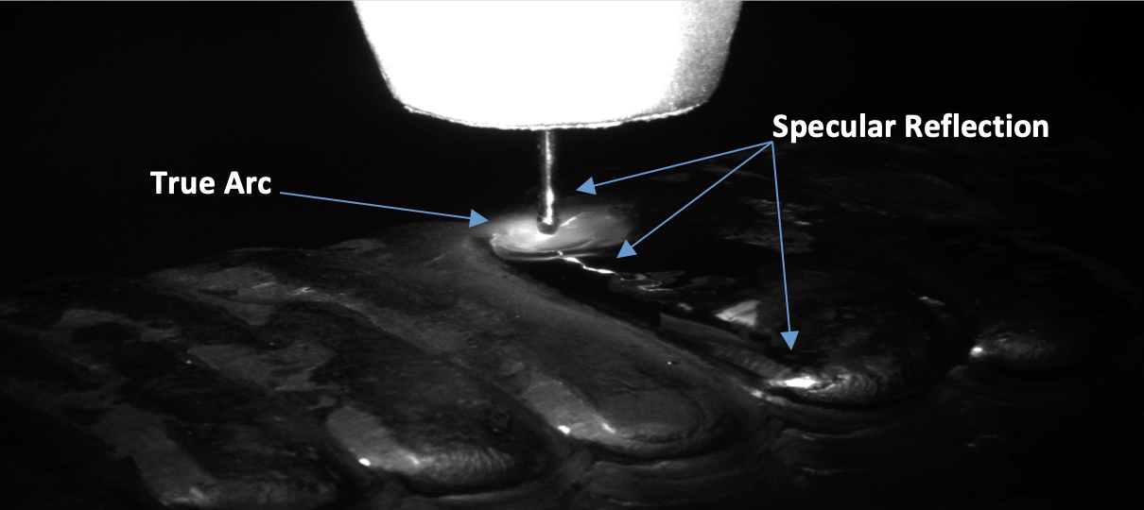
Experimental setup and the reflection ambiguity motivating this work.

4 Methodology
The pipeline begins from an adaptive ROI stage (Section 4.1) that crops the arc/wire/bead zone; the deterministic detector then applies glare removal followed by reference-frame differencing (Section 4.2), and a temporal rule converts per-frame decisions into an anomaly signal (Section 4.3).

4.1 Adaptive ROI Extraction
The ROI stage crops each frame to a fixed $512×512$ pixels window. Since raw pixel values depend on exposure and gain, it uses no fixed brightness or size thresholds; every value is computed from each frame’s own statistics, and the only preset is the $512×512$ output size. After greyscale conversion the ROI is found in three steps. Torch detection: the torch, being the brightest object, is isolated by a threshold at the natural valley in the upper part of the intensity histogram; after light morphological cleaning, the largest bright region gives the wire centre and torch lower edge, and a vertical corridor of width proportional to the torch is defined around the wire centre. Arc/glow bottom detection: the lower edge of the arc-and-glow zone is found by scanning down the corridor, treating a row as bead only if it is both bright and wide enough, stopping after a short run of dark rows. Cropping: the ROI spans the corridor from just above the torch bottom to the detected edge, then is fixed to $512×512$ by anchoring at the top, so arc activity always appears in the upper region. The self-calibrating parameters are listed in Table 1.
Self-calibrating parameters of the ROI stage.
Parameter | Value / rule
Output size | $512×512$ (fixed; CNN input dimension)
Torch threshold | histogram valley in the upper intensity range
Erosion kernel | % of image height (scales with resolution)
Corridor half-width | % of torch height
Bead brightness threshold | dark-gap median $+$ 10% of torch brightness (clamped 15–120)
Bead width threshold | % of corridor width
Dark-streak stop / max scan depth | % / 45% of image height
Crop padding | % of image height (top and bottom)

4.2 Glare Removal and Arc Detection
Glare removal. Each crop passes through a specular-glare-removal stage. A glare mask combines two cues; a high-percentile near-saturation threshold, which captures the brightest reflection cores, and a morphological white top-hat, which captures small, sharp specular peaks on the wire and bead. The mask is cleaned of speckles, slightly dilated to include the halo around each spot, and inpainted by diffusion, with a short feathering ramp along the boundary. Reflections from the molten pool, wire, and solidified surface are the dominant sources of false “arc-present” detections and are therefore suppressed before the arc-state decision is made.
Arc detection by reference differencing. An “arc-off” reference is selected automatically as the darkest of the first 50 frames. Every subsequent frame is evaluated by two tests. A brightness-drop test judges the frame arc-off (and replaces the reference) if its mean brightness falls more than a small margin below the reference. Otherwise, a change test counts pixels whose absolute difference from the reference exceeds an intensity threshold and declares the arc present when this count exceeds a count threshold. When a frame is judged arc-off and also stays close to the original reference, the reference is re-anchored to it, so the detector tracks slow illumination drift without latching onto a transient reflection or a genuine arc.
Threshold selection. The three free parameters(intensity difference, changed-pixel count, and brightness-drop margin)were fixed by an exhaustive grid search over the full video against the labels, giving 56 (on 0–255), 600, and 0.5, respectively. The same values were used for both videos without per-video adjustment, which underlies the cross-video consistency reported in Section 5.

4.3 From Per-Frame Decisions to Anomaly Alerts
An alert is not raised from a single frame. Isolated misclassifications are expected, especially during ignition and extinction transients, so a temporal rule declares an anomaly only when the arc is absent for a sustained run of consecutive frames while a deposition path is executing; a short run is tolerated silently. The threshold is grounded in process timing; at 30 fps each frame spans $1/30≈33.3$ ms, so a run of $N$ no-arc frames corresponds to $t=N×33.3$ ms. At the confirmed macroscopic short-circuit frequency $f≈150$ Hz, the number of welding cycles is $n=t×f$; a run of nine frames ($≈0.3$ s) thus spans $≈45$ cycles, which cannot be explained by normal short-circuiting flicker and instead indicates a genuine deviation. Rather than being fixed by hand, the threshold is read from the empirical no-arc streak distribution (Section 5). An alarm level at the 95th percentile and a critical level at the 99th percentile, beyond which a safe stop can be triggered. The metrics below are frame-level which is the more conservative measure, so event-level alerting performance is better than frame-level recall alone suggests.

5 Results and Discussion

5.1 Frame-Level Detection Performance
The method was evaluated on Video 1 (Layer 6) and Video 2 (Layer 39), comparing each frame’s output against its label after alignment, with arc-ON as the positive class. It performed strongly and consistently (Table [tab:results]). On Video 1 it reached 86.8% accuracy and 88.1% F1, identifying 3,404 of 3,976 arc-ON frames (recall 85.6%) and 2,625 of 2,972 arc-OFF frames (specificity 88.3%) at 90.7% precision. On Video 2 every metric improved; accuracy 90.6%, F1 91.7%, recall 88.8%, precision 94.8%, specificity 93.2%; since both videos come from the same process, the higher scores likely reflect more favourable imaging conditions, not re-tuning. Pooled ($n=13,863$), the method achieved 88.7% accuracy, 92.8% precision, 87.2% recall, 90.7% specificity and 89.9% F1.
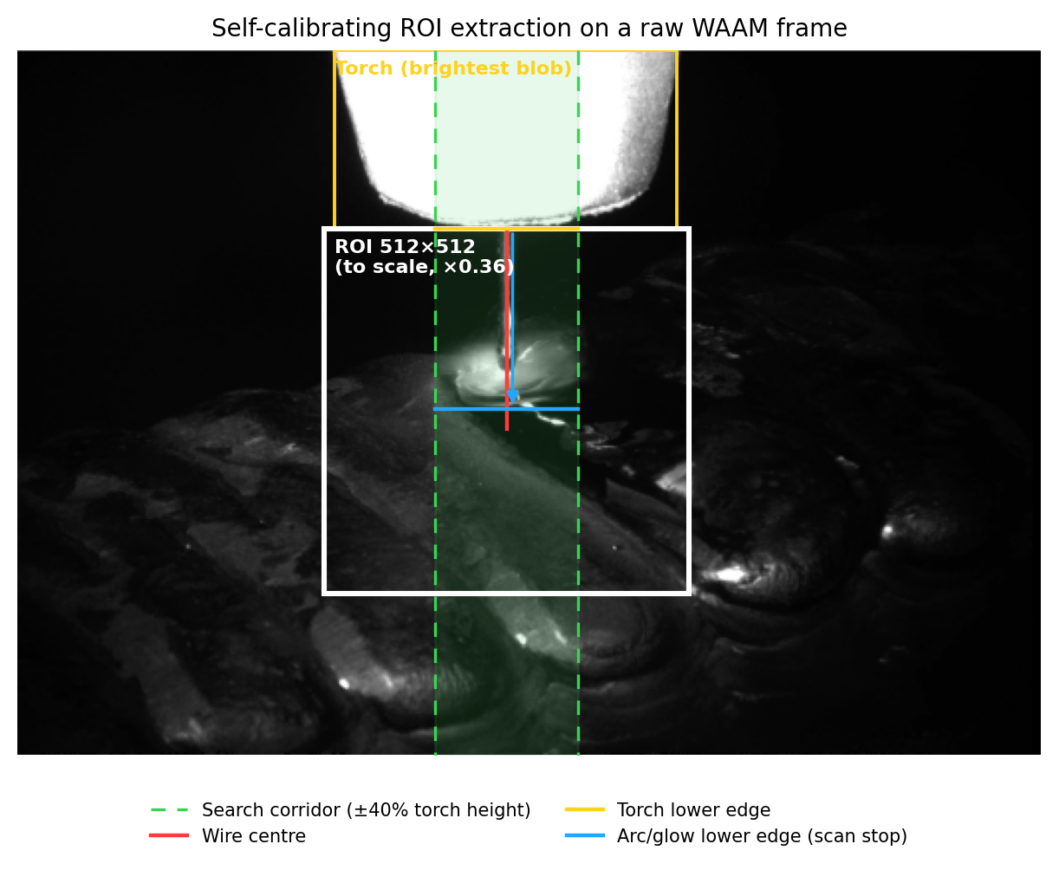
Distribution of no-arc streak lengths.
lCCC Metric & Video 1 (L6) & Video 2 (L39) & Combined
Frames compared & 6,948 & 6,915 & 13,863
Accuracy & 86.8% & 90.6% & 88.7%
Precision & 90.7% & 94.8% & 92.8%
Recall (arc-ON) & 85.6% & 88.8% & 87.2%
Specificity (arc-OFF) & 88.3% & 93.2% & 90.7%
F1-score & 88.1% & 91.7% & 89.9%
Error analysis. On both videos, false positives were far fewer than false negatives. 347 vs. 572 (Video 1) and 197 vs. 452 (Video 2), pooling to 544 vs. 1,024. False positives are the error mode driven by specular reflection (a bright non-arc region mistaken for the arc), and their low count indicates the glare-removal front-end effectively suppresses reflection-induced false detections. The residual error is instead concentrated in missed arc-ON frames at ignition and extinction, where the arc is faint and its change relative to the reference is small. For a safety-oriented monitor this is favourable, since the method rarely raises a false arc-present signal, and the missed transition frames are brief and are absorbed by the temporal rule.
The key practical result is that a single, un-retuned parameter set generalised across two recordings separated in time, with all metrics within about five percentage points of each other. It supports its use as a lightweight, explainable safety layer.

5.2 Temporal Anomaly Analysis
The per-frame output was reduced to consecutive no-arc streaks, whose length distribution is strongly right-skewed (Figure 3); the median streak is only 2 frames ($≈$67 ms), confirming that brief no-arc readings are normal and should never alone raise an alarm. Two thresholds follow: an alarm threshold at the 95th percentile (5 frames, $≈$167 ms) and a critical threshold at the 99th percentile (9 frames, $≈$300 ms), beyond which a sustained loss of arc is treated as a likely fault. A noisy per-frame signal is thus converted into a robust, interpretable two-tier interlock that needs only a standard 30 fps camera and reacts within a fraction of a second while tolerating the benign drops inherent to the process.
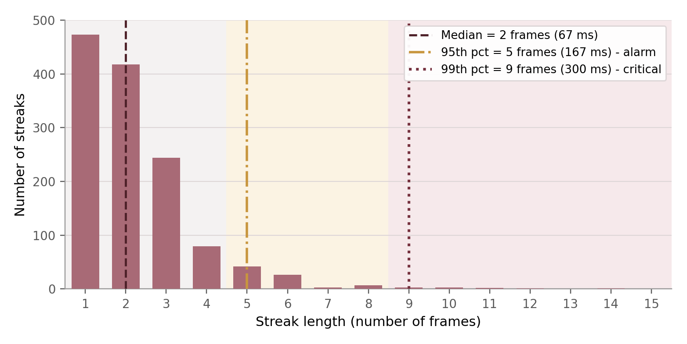
Distribution of no-arc streak lengths.

5.3 Discussion
The lower frequency of false “arc-present” detections suggests that glare removal effectively suppresses reflection-induced false alarms, which was the primary purpose of introducing this preprocessing step. The WAAM vision literature has generally treated specular reflection as an obstacle to tolerate, filter optically, or absorb into a learned model; the arc region has been deferred as too difficult (lee?), only an autoencoder could separate spatter from reflection (franke?), peak-current glare has been handled by discarding the affected frames (si?), and intense arc illumination has been framed as the central obstacle to melt-pool monitoring (kim?). The present results suggest a complementary route for binary arc-state detection or reflection can be attacked directly with cheap, transparent morphological pre-processing, after which a simple differencing rule becomes competitive.
A single parameter set transferred between Layers 6 and 39 despite different thermal state, glow extent and spatter. This is attributable less to the three tuned thresholds than to what was left untuned; the ROI stage contains no fixed brightness or size values, so the quantities that vary between recordings absolute brightness, apparent scale, glow extent are normalised away before the scalar thresholds are applied. Generalisation is therefore a property of the design. The residual error supports this; missed detections concentrate where the frame simply lacks a strong arc signature, an information limit of single-frame differencing rather than a tuning failure.
The monitor requires no modification of the cell (unfiltered RGB, no dedicated optics), runs within the frame period on a single CPU core, and yields trustworthy alerts; every alert traces to an interpretable quantity the number of changed pixels relative to an explicit reference. Evaluating on unfiltered production footage also directly addresses the reported gap between benchmark performance and real deployment (baitieva?).
The evaluation uses two recordings from a single build, cell, material and camera pose; the cross-video result therefore supports, but does not prove, the hardware-independence claim, which rests on the pipeline design. Ground truth was set by visual inspection, ambiguous on the transition frames where most errors fall. Future work includes validation across cells, materials and viewpoints (e.g. WAAM-ViD (kim?)), temporal modelling of short sequences, benchmarking a learned detector on identical frames, and extending the binary primitive to continuous descriptors for closed-loop control.

6 Conclusions
This paper addressed a monitoring primitive the WAAM vision literature has largely passed over.The visible welding arc is treated as a safety-oriented binary state, based on its presence or sustained absence, rather than as illumination to be filtered out, using unfiltered RGB video without narrowband optics or HDR acquisition. A self-calibrating adaptive ROI stage, containing no fixed brightness or size values, feeds a deterministic detector that suppresses specular glare explicitly before detecting the arc by reference-frame differencing, with a temporal rule converting per-frame decisions into alerts. On two labelled recordings separated in time and thermal state (13,863 frames), one un-retuned parameter set reached 88.7% accuracy and 89.9% F1, with errors falling predominantly on missed weak arcs at ignition and extinction rather than reflections misread as arcs, confirming that glare removal substantially suppresses reflection-induced false alarms. Requiring no dedicated optical hardware, per-video calibration, accelerator or training data, it is directly deployable as a lightweight, explainable safety layer on existing WAAM camera streams and supplies the perception front-end for future closed-loop control.
-0cm
999
Norrish, J.; Polden, J.; Richardson, I. A review of wire arc additive manufacturing: development, principles, process physics, implementation and current status. J. Phys. D Appl. Phys. 2021, 54, 473001.
Gourakani, M.; Mineo, C.; Cerniglia, D.; Bertazzo, A.; Tiso, F.; Avallone, G. Visual and thermal monitoring techniques for Wire Arc Additive Manufacturing: from conventional to machine learning approaches. Discov. Appl. Sci. 2026, 8, 700.
Gao, Q.; et al. Investigation of arc stability in wire arc additive manufacturing of 2319 aluminum alloy. Materials 2024, 17, 5160.
Xia, C.; Pan, Z.; Li, Y.; et al. Vision-based melt pool monitoring for wire-arc additive manufacturing using deep learning method. Int. J. Adv. Manuf. Technol. 2022, 120, 551–562.
Franke, J.; Heinrich, F.; Reisch, R.T. Vision based process monitoring in wire arc additive manufacturing (WAAM). J. Intell. Manuf. 2025, 36, 1711–1721.
Lee, C.; Seo, G.; Kim, D.B.; Kim, M.; Shin, J.-H. Development of defect detection AI model for Wire + Arc Additive Manufacturing using high dynamic range images. Appl. Sci. 2021, 11, 7541.
Kim, K.W.; Kamerkar, A.; Chiu, T.-E.; Abdi, I.; Qin, J.; Suder, W.; Asif, S. WAAM-ViD: towards universal vision-based monitoring for wire arc additive manufacturing. Front. Manuf. Technol. 2025, 5, 1676365.
Si, J.; Luo, L.; Liu, C.; Lu, J. Arc length monitoring and closed-loop quality control for GTA-WAAM. Virtual Phys. Prototyp. 2025, 20, e2513004.
Zeng, J.; Chang, B.; Du, D.; Hong, Y.; Chang, S.; Zou, Y. A precise visual method for narrow butt detection in specular reflection workpiece welding. Sensors 2016, 16, 1480.
Baitieva, A.; Bouaouni, Y.; Briot, A.; Ameln, D.; Khalfaoui, S.; Akcay, S. Beyond academic benchmarks: critical analysis and best practices for visual industrial anomaly detection. In Proc. IEEE/CVF Conf. on Computer Vision and Pattern Recognition (CVPR) Workshops, 2025; pp. 4054–4064.
Gourakani, M.; Mineo, C.; Cerniglia, D.; Bertazzo, A.; Tiso, F.; Avallone, G. Defect classification in wire arc additive manufacturing via a semi-supervised teacher–student model. In Proc. 14th European Conf. on Non-Destructive Testing (ECNDT 2026), Verona, Italy, 15–19 June 2026.
Reisch, R.; Hauser, T.; Lutz, B.; Pantano, M.; Kamps, T.; Knoll, A. Distance-based multivariate anomaly detection in wire arc additive manufacturing. In Proc. 2020 19th IEEE Int. Conf. on Machine Learning and Applications (ICMLA), 2020; pp. 659–664.
Mattera, G.; Nele, L.; Vozza, M. Frequency-informed convolutional autoencoder for in-situ anomaly detection in wire arc additive manufacturing. J. Intell. Manuf. 2024.
Nele, L.; Mattera, G.; Vozza, M. Deep neural networks for defects detection in gas metal arc welding. Appl. Sci. 2022, 12, 3615.
Xiong, J.; Zhang, G. Online measurement of bead geometry in GMAW-based additive manufacturing using passive vision. Meas. Sci. Technol. 2013, 24, 115103.
Couto, M.O. Mapping of bead geometry in wire arc additive manufacturing systems using passive vision. J. Control Autom. Electr. Syst. 2022, 33, 1136–1147.

